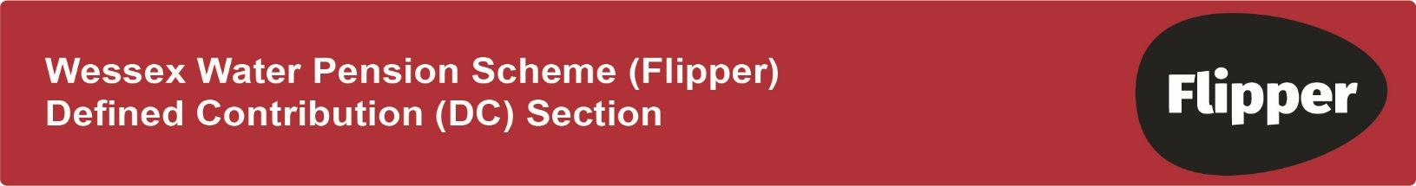
ADDITIONAL VOLUNTARY CONTRIBUTIONS – AVCS
Please complete this form ONLY if you wish to pay voluntary contributions above the standard 5% level.
AVC contributions will be paid by the Scheme’s Salary Exchange arrangement.

Your details
Full name (capital letters)……......................................................................................................

Date of Birth ……………………..…………………… Employee number ….……………………
- I confirm I wish to pay AVCs as detailed below and understand that my AVCs will be invested in the same fund/s with the same % split if applicable as my regular pension contributions.
- I understand these are voluntary contributions I have chosen to make above the standard 5% contribution level. I understand the company will not increase its contribution above the standard 8% contribution level.
- As notified in your contract of employment an arrangement called salary exchange will automatically apply unless the Company notifies you otherwise or you choose to opt out of salary exchange.
- In order for AVCs to be approved by HMRC as a salary exchange arrangement I confirm my commitment to continue my AVCs for the duration of the tax year.
- I am aware HMRC requires contributions to be paid at broadly the same level for each tax year.

Further details about Salary Exchange are explained overleaf

Signed …………………………………….. Date ………………………

Your contributions (please state fixed cash amount £)

I wish to start paying AVCs of £……………… per month

or

I wish to amend my AVCs to £……………….. per month

Date you want to start or amend your contributions 1st ……………………….………………….

Should you wish to review your investment choice for both your regular and AVC contributions please note the Investment Guide or online at http://www.legalandgeneral.com/wessexwater will provide more information on the funds available. The trustees recommend that you seek advice from an independent financial adviser. Please note the trustees are not liable in any way for the investment decisions you make (or fail to make). They will review the range of funds available and take advice for this purpose. However, you are exclusively responsible for the investment decisions you make for the investment of your personal account.

The trustees cannot give you investment advice. IFA Promotions can provide details of independent financial advisers in your area www.unbiased.co.uk

Please return this form to : Pensions team, Wessex Water, Claverton Down, Bath, BA2 7WW

What is Salary Exchange?

Salary exchange is a simple way to increase your take-home pay, whilst also helping the company to save money. Salary exchange does not change the amount of money paid into your personal account.
Salary exchange increases the amount of your take-home pay by reducing the National Insurance (NI) contributions you pay. The company also benefits from reduced NI costs for members who take up salary exchange. Overall, it is an efficient way of delivering NI savings and as a consequence, is of mutual benefit to the employee and the company.

How does it work?

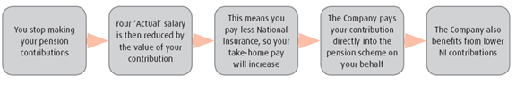

Salary Exchange is a change to your terms and conditions of employment. Once you participate, you are required to continue in Salary Exchange. If you wish to opt out at any stage in the future should certain lifestyle events lead to a change in your circumstances you will be required to complete an Opt Out form and send to the Pensions Team. If the Government changes the rules on Salary Exchange then the Company will review the position for all employees, which may result in a change to the terms and conditions for all members.

Will Salary Exchange affect my income tax position?

There will be no change.

For Payroll use :
AVC Salary Exchange Pension code | (SS) DC AVC £
Amount
Pension Code effective date:
Signed:
Checked:

